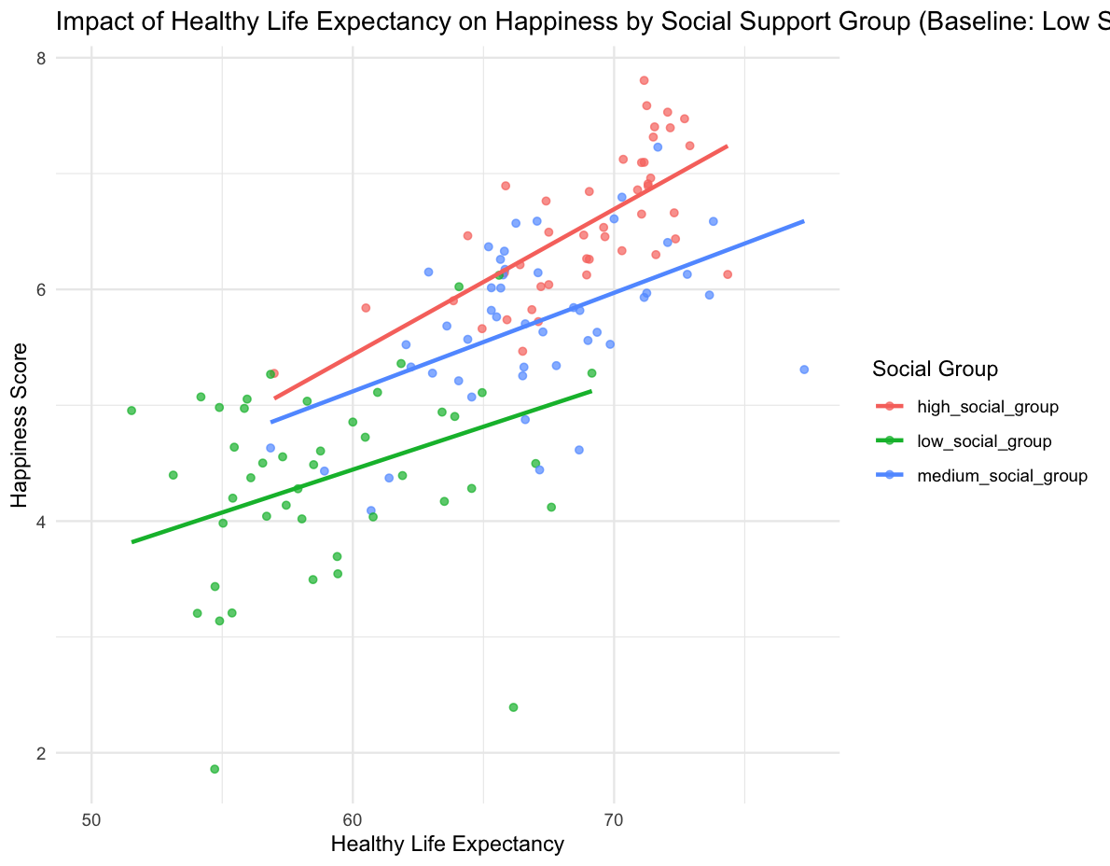
Figure 4: Impact of Healthy Life Expectancy on Happiness by Social Support

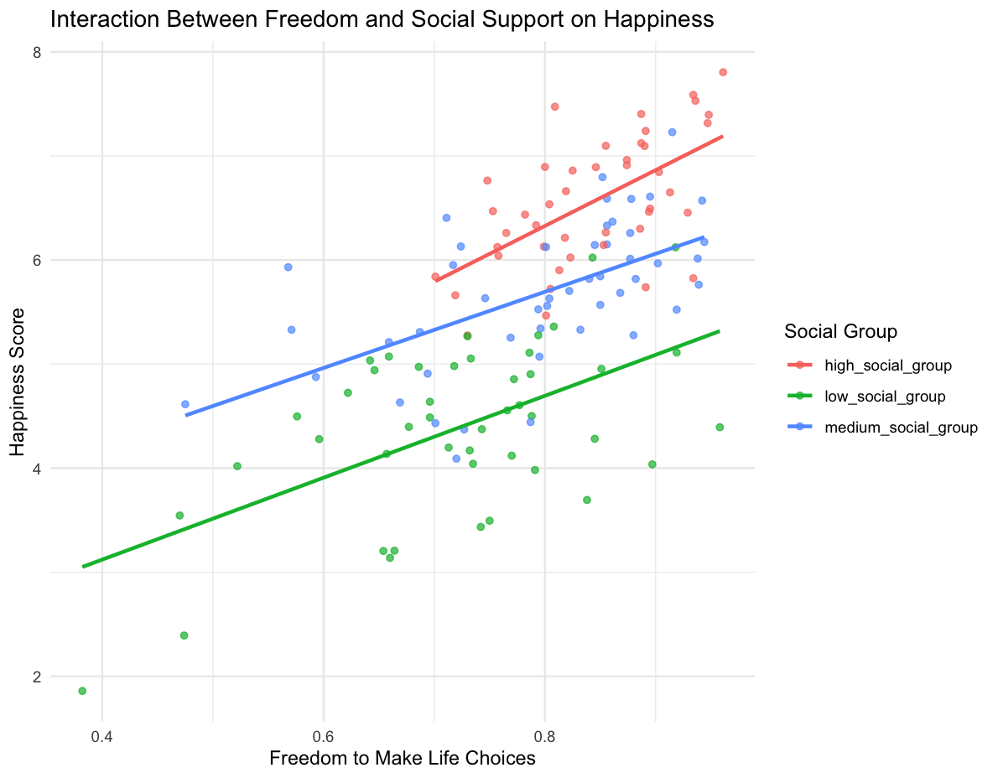
Figure 5: Interaction Between Freedom and Social Support on Happiness
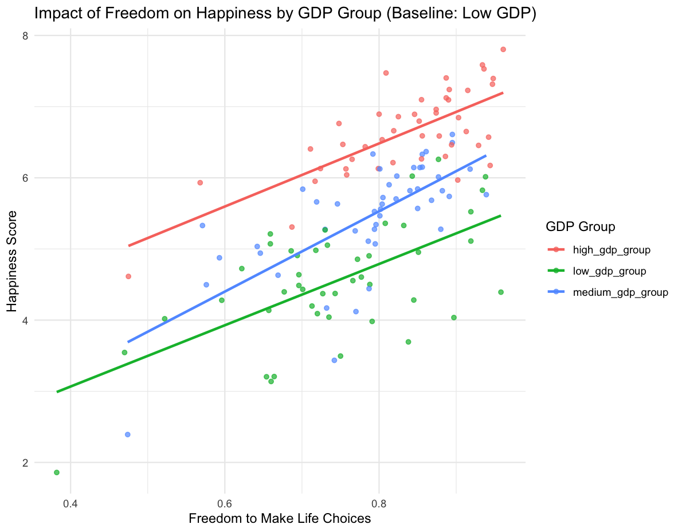
Figure 6: Impact of Freedom on Happiness by GDP Group

